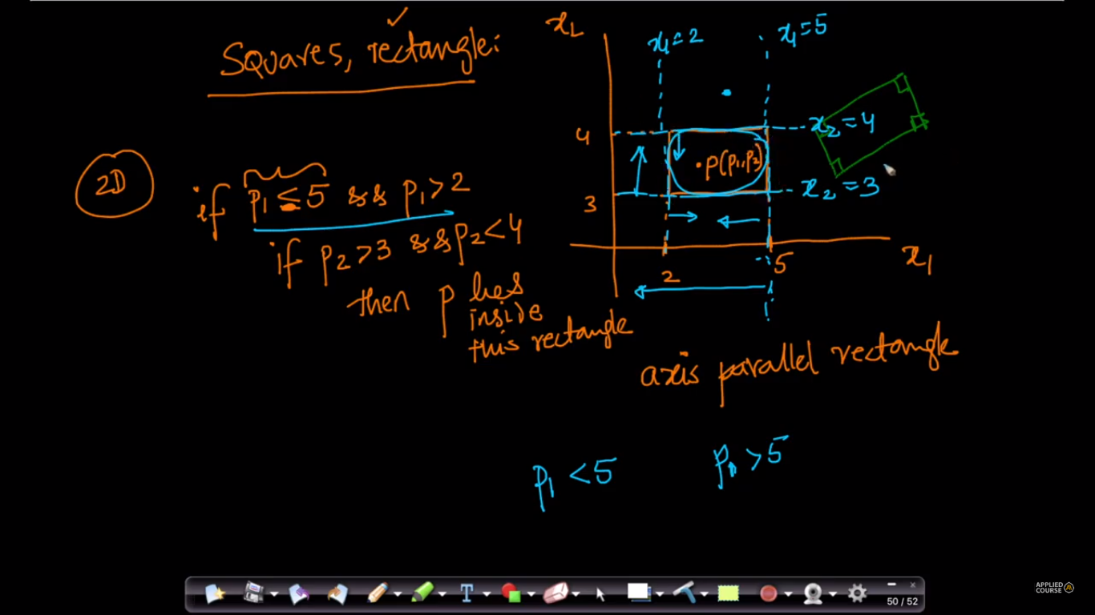

If a rectangle/square is parallel to axis then we can directly say that whether point is within rectangle or not by just seeing coordinate.

But if it’s not parallel to axis then we’ve to find where point is (by method we saw in plane finding direction of point wrt plane) considering each edge of rectangle as line.

If that point within all the lines then it’s within the rectangle.